***LOGIC*: Argument**: a sequence of statements, one of which is flagged as the conclusion. **Valid** if (p1∧p2∧···∧pn)→q is a tautology. The other statements, called **Premises**, are alleged to justify the conclusion. **Conditional statements:** statements of the form p→q and p↔q. **Compound statements** are statements built from other statements using logical connectives. **Discrete mathematical models** are abstract representations of processes and objects, the steps or units of which can be indexed by the non-negative integers. The **Converse** of p→q is q→p**.** The **Contrapositive** of p→q is ¬q→¬p. **Discrete mathematics** is the study of discrete mathematical models. The **Inverse** of p→q is ¬p→¬q. We say that the set {∧,(∨),¬} is **Functionally complete**. **Logical connectives** e.g. ‘and’, ‘or’, ‘not’, ‘if-then’, ‘if and only if’ may be used to glue the statements together to make new statements. p is a **Necessary condition** for q means ¬p→¬q or q→p. p is a necessary and sufficient condition for q means p↔q. **Predicate:** a sentence containing one or more variables, with the property that, when a value from a specified domain (for the predicate) is given to each variable, the sentence becomes a statement. **Statement**: a sentence that is true or false but not both. E.g. 3 > 2. **Statement variable:** when a variable represents an arbitrary statement. **Statement form**: an expression built using statement variables, parentheses and logical connectives if the expression becomes a statement when actual statements are substituted for the component statement variables.e.g. q∨¬(p∧q). **Vacuously true**: when the hypothesis in a conditional is false. p is a **Sufficient condition** for q means p→q.

**等价: 否定**: ¬(¬p)≡p; ¬(p∧q)≡¬p∨¬q; ¬(p∨q)≡¬p∧¬q; ¬(p⊕q)≡(p∧q)∨(¬p∧¬q); ¬(p→q)≡p∧¬q; ¬(p↔q)≡(p∧¬q)∨(¬p∧q). **NAND:** ¬X≡X↑X; X∧Y≡¬(X↑Y)≡(X↑Y)↑(X↑Y);

***SETS*:** **Cartesian product**: Given (not necessarily distinct) sets A1, A2, ..., An, the Cartesian product of A1, A2, ..., An, denoted A1×A2×···×An, is the set of all ordered n-tuples (a1, a2, ..., an) where a1∈A1, a2∈A2, ..., an∈An. i.e. {(a1, a2, ..., an) | a1 ∈ A1, a2 ∈ A2, ..., an ∈ An}. **Composite number**合数. The I**nverse** R−1 of a relation R ⊆ A × B is the relation R−1⊆B×A defined by R−1={(b, a)∈B×A; (a, b)∈R}. Sets A, B are called **Disjoint** when A∩B=∅. We say that A **Equals** B, written A=B, when A⊆B and B⊆A. **Ordered n-tuple:** 元组, order maters.(a,b,c). **Prime number**质数. We say that A is a **Proper subset真子集** of B, or A is **Properly contained** in B, and write A(不包含于)B, when every element of A is in B but there is at least one element of B that is not in A. **Power set**: P(A) has 2n elements. **Pairwise disjoint**: the sets in set S are ∀A, B∈S A≠B→A∩B=∅. **Partition**: Let S be a set and A ⊆ P(S) and each of the following statements is true: 1. ∅∉A, 2. every element of s is an element of some set in A, 3. the sets in A are pairwise disjoint. **Set:** a collection of elements.

**符号:** **Union**: U; **Intersection**: ∩; **Difference:** B−A or B\A; **Complement补:** Ac; **Symmetric difference对称差**: A△B;

**表示: Set-roster:** T = {2, 3, 5, 7, ...}. **Set-builder:** {x∈D | p(x)}. **Partition:** 分割, A = {{1}, P, C} is a partition of Z+.\



**等价:**

***RELATIONS & FUNCTIONS*: Composition** of function g and f and denoted g◦f, (g◦f)(a)=g(f(a)), order matters. **Directed Graph** or **Digraph**: 有向图. A relation f from set A to set B is called a **Function** from A to B when ∀a∈A ∃!b∈B (a, b)∈f. **Fermat’s little theorem**: If p is prime and a∈N satisfies gcd(a, p)=1 then ap−1 mod p=1. The **Greatest Common Divisor** of a, b ∈ N, written **gcd**(a, b), is the largest n∈N such that a mod n = 0 and b mod n = 0. If **gcd**(a, b) = 1, a, b are called **Relatively Prime.** Let f : A → B be a function. We say that f is **one-to-one** or f is I**njective** or f is an **injection** when ∀a1, a2∈A (a1≠a2)→(f(a1)≠f(a2)). **Relation**: any subset of A×B is called a **Relation from** A to B, a relation from A to A is called a **relation on** A. The **Inverse** R−1 of a relation R⊆A×B is the relation R−1 ⊆B×A defined by R−1 ={(b, a)∈B×A; (a,1b)∈R}. Let function f: A → B, we say that f is onto or f maps onto B or f is **Surjective** or f is a **Surjection** when ∀b∈B ∃a∈A f(a)=b. f is **Bijective** or f is a **Bijection** when f is injective and surjective.

**等价：**

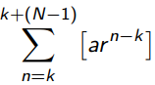***DIGITAL INFORMATION:*  负数补码计算：取反加一改符号位。**

**等价：**aRnb⇔∃k∈Z a=b+kn⇔a ≡ b (mod n);

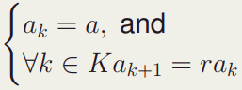***SEQUENCES*:**

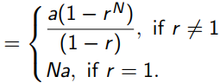**Geometric Sequence等比数列:** **求和：**

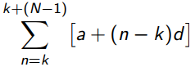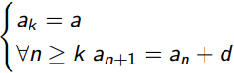

**Arithmetic Sequences等差数列:求和：**

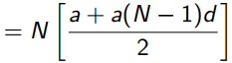

**Mixed Geometric-Arithmetic Sequences混合数列：**

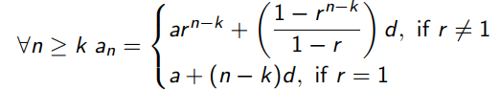**显式定义：** 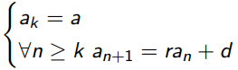



**求和：**

**选择排序：**第一次从待排序的数据元素中选出最小的一个元素，存放在序列的起始位置，然后再从剩余的未排序元素中寻找到最小元素，然后放到已排序的序列的末尾。以此类推，直到全部待排序的数据元素的个数为零。

**数学归纳法例子mathematical induction：**

